WEBSITE PROJECT PROPOSAL

Sweet Crust Bakery & Tech Solutions Inc.

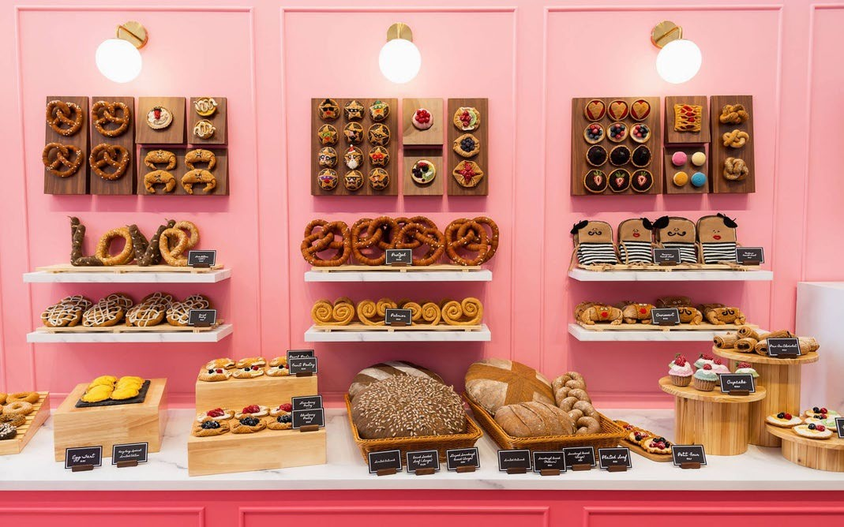

Student Name: [Christian Gowera]

Student Number: [ST10490935]

Module: WEB DEVELOPMENT (INTRODUCTION)

Module Code: WEDES020/p/w

Date: [2025/29/09]

Contents
SWEET CRUST BAKERY & TECH SOLUTIONS INC 1
Student Name: [Christian Gowera] 1
Student Number: [ST10490935] 1
Module: WEB DEVELOPMENT (INTRODUCTION) 1
Module Code: WEDES020/p/w 1
Date: [2025/29/09] 1
PROPOSAL 1: SWEET CRUST BAKERY 3
1. Organization Overview 3
2. Website Goals and Objectives 3
3. Key Features and Functionality 4
4. Site Map Structure 5
5. Timeline and Milestones 5
PROPOSAL 2: TECH SOLUTIONS INC 6
1. Organization Overview 6
2. Website Goals and Objectives 6
3. Key Features and Functionality 7
4. Site Map Structure 7
5. Timeline and Milestones 8
[SIMILAR STRUCTURE TO PROPOSAL 1] REFERENCES 8

1

PROPOSAL 1: SWEET CRUST BAKERY

1. Organization Overview

Name: Sweet Crust Bakery
Industry: Food & Beverage - Artisan Bakery
Established: 2020

Mission Statement: To provide high-quality, freshly baked artisan goods using locally sourced ingredients while maintaining traditional baking methods with modern creativity.

Target Audience:
- Residents (25-65 years)
- Event planners and catering companies
- Corporate clients for office deliveries
- Health-conscious consumers (gluten-free, vegan options)

2. Website Goals and Objectives

Primary Goals:
- Increase online visibility and brand recognition by 40% within 6 months
- Generate 50+ monthly online inquiries for custom orders
- Establish as the premier local artisan bakery

Specific Objectives:
- Showcase product portfolio with high-quality imagery
- Provide easy access to business information (hours, location, contact)
- Implement lead generation for custom cake orders
- Build email newsletter subscriber base

3. Key Features and Functionality

Part 1 Features:
- 5-page responsive website structure - Product categorization and filtering
- Gallery showcasing bakery creations
- Contact form with location map
- SEO-optimized content structure

Technical Specifications:
- HTML5 semantic markup
- CSS3 styling with responsive design
- Mobile-first approach
- Cross-browser compatibility

4. Site Map Structure

Home
├── About Us (Our story, team, philosophy)

├── Products
│ ├── Artisan Breads
│ ├── Pastries & Desserts
│ ├── Custom Cakes
│ └── Seasonal Specials
├── Gallery (Portfolio of work)
├── Contact (Location, hours, form)
└── Footer (social media, newsletter)

5. Timeline and Milestones

Week 1-2: Part 1 Completion
- Days 1-3: Project planning and research
- Days 4-7: HTML structure development
- Days 8-10: Content integration
- Days 11-14: Testing and submission

Resources Required:
- Visual Studio Code
- Git version control
- GitHub repository
- Royalty-free image sources

PROPOSAL 2: TECH SOLUTIONS INC.

1. Organization Overview

Name: Tech Solutions Inc.
Industry: IT Services & Consulting
Established: 2018

Mission Statement: To provide comprehensive IT solutions and digital transformation services to small and medium-sized businesses.

Target Audience:
- Small to medium businesses (10-200 employees)
- Startups requiring technical infrastructure
- Enterprises needing specialized IT consulting

2. Website Goals and Objectives

Primary Goals:
- Generate qualified leads for IT services
- Establish thought leadership in IT consulting
- Showcase successful case studies and client testimonials

Specific Objectives:
- Increase service inquiries by 60% within 6 months
- Build email list of 1,000+ subscribers
- Position as industry experts through blog content

3. Key Features and Functionality

Part 1 Features:
- Service portfolio with detailed descriptions
- Case studies and success stories
- Team expertise showcase
- Client testimonial section
- Service inquiry forms

4. Site Map Structure

Home
├── Services (IT solutions offered)
├── Case Studies (Client success stories)
├── About (Company history, team)
├── Blog (Industry insights)
├── Contact (Consultation requests)
└── Client Portal (Existing clients)

5. Timeline and Milestones

[Similar structure to Proposal 1]
REFERENCES

- Harvard Style Referencing Guide - Adapted for the IIE
- All images sourced from Unsplash.com and Pexels.com with proper attribution
- Color palette inspiration from Coolors.co
- Typography guidelines from Google Fonts

